Date – September 14, 2023

## Activity 4

**Aim:** Calculate the arithmetic mean, geometric mean and Harmonic mean (5Hrs).

# **Learning outcome**: Able to understand the Business Analytics.

###### Duration: 5 hours

# List of Hardware/Software requirements:

* Laptop/Computer with Windows
* MS Office with Excel

# Arithmetic mean

Arithmetic Mean, commonly used term in statistics, is the average of the numerical values set and is calculated by firstly calculating the sum of number in the set and then dividing resultant by count of those numbers.

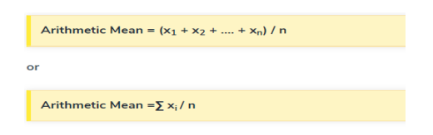

# Geometric mean

In mathematics, the geometric mean is a mean or average, which indicates the central tendency or typical value of a set of numbers by using the product of their values (as opposed to the arithmetic mean which uses their sum). The geometric mean is defined as the nth root of the product of n numbers, i.e., for a set of numbers x1, x2, ..., an, the geometric mean is defined as

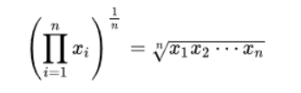

In two dimensions, it is the equivalent of finding the equivalent square with the same area as the rectangle given by the two dimensions cited:

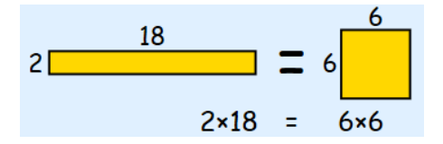

In three dimensions, it is the equivalent of finding the equivalent cube with the same volume as the given hexahedron with the three dimensions cited:

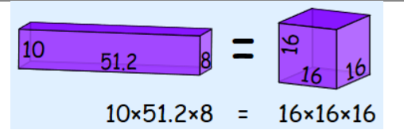

The idea continues in n dimensions.

The Excel function GEOMEAN returns the geometric mean of an array or range of positive data. For example, you can use GEOMEAN to calculate average growth rate given compound interest with variable rates. It has the following syntax:

GEOMEAN (number1, [number2], ...)

The GEOMEAN function has the following arguments:

* number1, number2...where number1 is required, and subsequent numbers are optional. There can be between one (1) and 255 numbers. You can also use a single array or a reference to an array instead of arguments separated by commas.

It should be further noted that:

* arguments can either be numbers or names, arrays, or references that contain numbers
* logical values and text representations of numbers that you type directly into the list of arguments are counted
* of an array or reference argument contains text, logical values or empty cells, those values are ignored; however, cells with the value zero are included
* arguments that are error values or text that cannot be translated into numbers cause errors
* if any data point ≤ 0, GEOMEAN returns the #NUM! error value
* the equation for the geometric mean is:

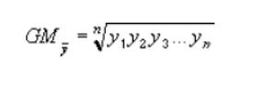

# Harmonic mean

The Excel HARMEAN function returns the harmonic mean for a set of numeric values. The harmonic mean is the reciprocal of the arithmetic mean of reciprocals. Harmonic mean can be used to calculate a mean that reduces the impact of outliers.



=HARMEAN (number1, [number2], ...)

● number1 - First value or reference.

● number2 - [optional] Second value or reference. Where:

X1, X2…Xn – Data Points

n – Total number of data points

# Arithmetic Mean (AM), Geometric Mean (GM) and Harmonic Mean (HM):

